FACE TO FACE APPOINTMENTS
If you’re attending the Surgery for an appointment with a Clinician or Nurse, please come inside the Surgery, use the check in screens and wait in the waiting room to be called through the screens.

REPEAT PRESCRIPTIONS:
If you have a repeat prescription request that you wish to order. You can order these online through Patient Access or the NHS App. If you don’t have this access set up, please speak to the reception team for more information.
You can also order through the repeat prescriptions Line on 01684 592696 (pressing option 3)
Monday to Friday 08.30am – 10.30am.
Post Box
You can tick your repeat prescription slip and post it in the box outside the main entrance. This box is emptied every day.

DISPENSARY OPENING TIMES:
If you have any queries about your medication or prescriptions, please speak to the Team at the Dispensary who will be able to help you.
Dispensary opening times to collect prescriptions: 08:30 am to 6:30 pm (weekdays)

What’s new at Upton Surgery?

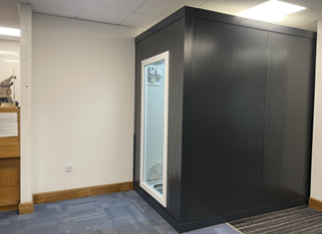
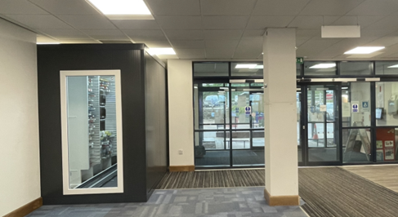
We now have a new Dispensing Robot at the Surgery. Our New Omnicell Robot is the next generation of picking robot that can automate the storing, management and dispensing of medication packs.

Dr A Havercroft and Partners
Upton Surgery
Tunnel Hill, Upton-upon-Severn
Worcs. WR8 0QL

Email: uptonsurgery@nhs.net
Website: www.uptondoctors.co.uk
Tel: 01684 592696
(08:00am – 6:30pm)

HOW TO BOOK AN GP APPOINTMENT WITH A GP.
Patients are requested to ring the Surgery on the day they wish to arrange an appointment. The reception team are working alongside a GP to determine the best route for the patient. Patients may then offered a telephone consultation slot with a Clinician or a face to face depending on the clinical reason. All patients are encouraged to continue to wear a face covering when attending the Surgery premises, if they have any flu like symptoms. You can also send an e-consult through www.uptondoctors.co.uk

HOW TO BOOK AN APPT WITH A NURSE/HCA:
Patients are requested to ring the Surgery to book these appointments on 01684 592696. Pressings option 2, this line is only open from 10am.

HOME VISITS:

All home Visits, will be booked through a clinician. Please speak to the Reception Team for more information if you require a home visit.

OUT OF HOURS CALL:

If you require non urgent medical advice or information you can contact NHS 111.
NHS 111 runs the Out of Hours GP service, available Monday to Friday 6.30pm – 8.00am, at weekends and over Bank Holidays. All calls are triaged and you may be asked to attend the nearest Primary Care Centre. If required a Doctors home visit will be organised.

WHEN SHOULD I GO TO THE SURGERY?:

You should come to the Surgery when you have a face to face appointment booked with a Clinician or Nurse. Please use the check-in screens to check yourself in and take a seat in the waiting room.

WHEN YOU SHOULD NOT CONTACT THE SURGERY:
In an emergency, or if you need urgent immediate assistance, dial 999.

OTHER LINKED SERVICES:

We share the building with some of our local Community Health services including Physiotherapists, and District Nurses. To find out how they are managing their appointments at the moment, please ring:
District Nurses – 0300 123 7593

ORDERING/COLLECTING MEDICATION:
All repeat prescription requests have a 7 day turn around to ensure we have your medication in stock ready for collection.
Please speak to the dispensary team if you have an queries.

We want to thank all our patients for their continued support over the course of the pandemic. We’re aware of recent media coverage around GP access and we are grateful for the many positive comments posted by patients which have supported our practice.

